|  |  |  |  |  |  |
| --- | --- | --- | --- | --- | --- |
| Test Scenario | Test Case | Test Data | Expected  Results | Actual  Result | Pass/Fail |
| Calculate Premium | Class A-C, Aged less 25  (Comprehensive)  Estimated Mileage (6000)  Claim in last 5 years (no) | Image Below (1) | £1900.00  £163.3 (with plus £5) | £1900.00  £158.3 | Fail (To correct add £5 to monthly) |
|  | Class D-E, Aged less 25  (Comprehensive)  Mileage (6000)  Claim in last 5 years (no) | Image Below (2) | £1500.00  £130 (with plus £5) | £1710.00  £142.50 | Fail (Incorrect calculation details with image) |
|  | Class A-C, Aged less 25  (Third party)  Estimated Mileage (6000)  Claim in last 5 years (no) | Image  Below (3) | £900.00  £80 (with plus £5) | £950.00  £79.17 | Fail |
|  | Class D-E, Aged less 25  (Third party)  Estimated Mileage (6000)  Claim in last 5 years (no) | Image  Below (4) | £500  £13.33 (with plus £5) | £855.00  £71.25 | Fail (incorrect calculation details with image) |
|  | Class A, Aged over 25  (Comprehensive)  Estimated Mileage (6000)  Claim in last 5 years (no) | Image  Below (5) | £1500.00  £130 (with plus £5) | £1520.00  £126.67 | Fail (incorrect calculation details with image) |
|  | Class A, Aged over 25  (Third Party)  Estimated Mileage (6000)  Claim in last 5 years (no) | Image  Below (6) | £500  £13.33 (with plus £5) | £760.00  £63.33 | Fail (incorrect calculation details with image) |

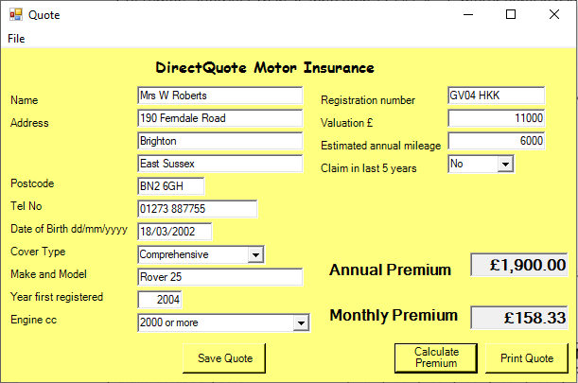

1 - This failed because of the missing £5 via monthly Premium.

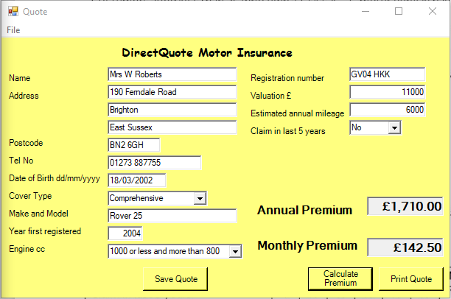

2 - This failed because of the missing £5 plus incorrect calculation of 75%.

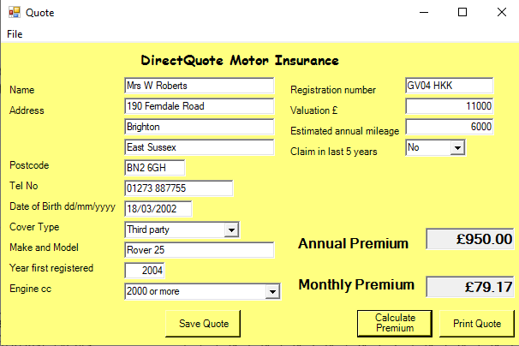

3 - This failed because of the missing £5 via monthly Premium plus 5% is calculated in the wrong order.

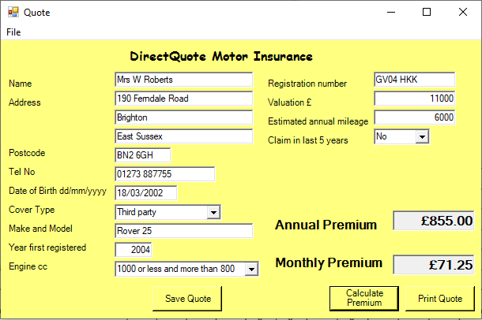

4 - This failed because of the missing £5 plus incorrect calculation of 75%.

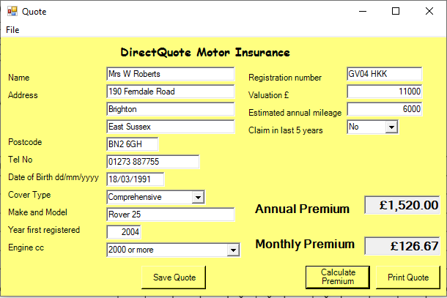

5 - This failed because of the missing £5 plus incorrect calculation of 75%.

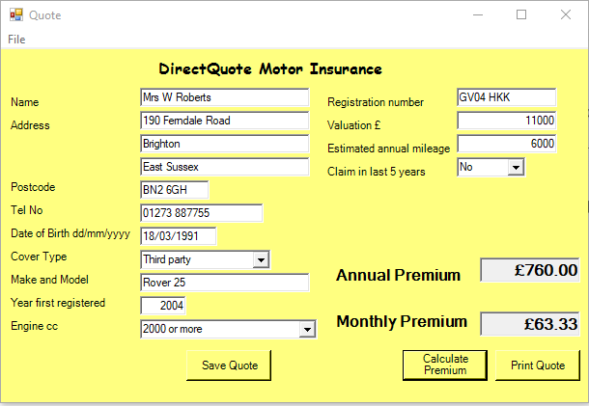

6 - This failed because of the missing £5 plus incorrect calculation of 75%.

Summary

From my finding the program consists of problems with calculations. Throughout all of my findings the additional £5 for monthly premium consists on all premiums. Have problems with calculating multiple percentages together creating different results based on the test case the table presented. The program needs looking into for calculations.